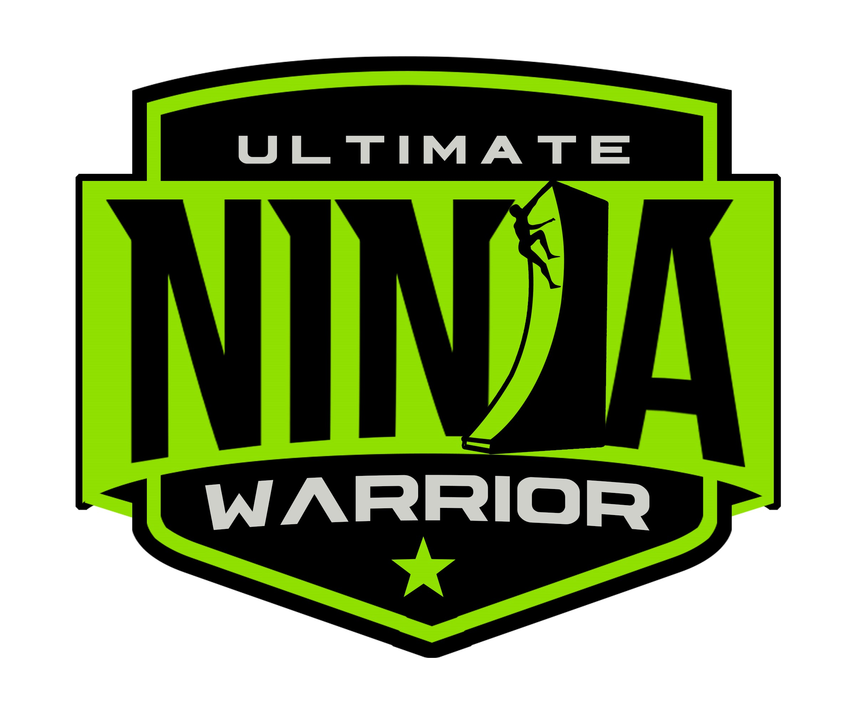
SUMMER 2021
NINJA WARRIOR CLASS SCHEDULE
Through 9/4

 | MONDAY | TUESDAY | WEDNESDAY | THURSDAY | FRIDAY | SATURDAY |  | SUNDAY
NINJA CUB  Pre-school |  | 5:30-6:30 PM | 4:30-5:15 PM
NINJA BEAR  Kindergarten | 5:30-6:15 PM |  |  | 5:00-5:45 PM
JUNIOR NINJA  7-10 years | 4:30-5:30 PM | 4:30 - 5:30 PM | 6:30-7:30 PM | 6:00-7:00 PM
PRE-TEEN/TEEN NINJA  11+ | 6:30-7:30 PM |  | 5:30-6:30 PM | 7:00-8:00 PM
NINJA OPEN GYM K+ | Coming  September | Coming  September | Coming  September | Coming  September | Coming  September

NINJA CLASS TUITION
45 Minute Class $110/Month
Drop-In $30 per Class

60 Minute Class $120/Month
Drop-In $35 per Class

Sibling Discount - $10
2nd Class Discount - $10
*Discounts cannot be combined

NINJA OPEN GYM
$20 per Person

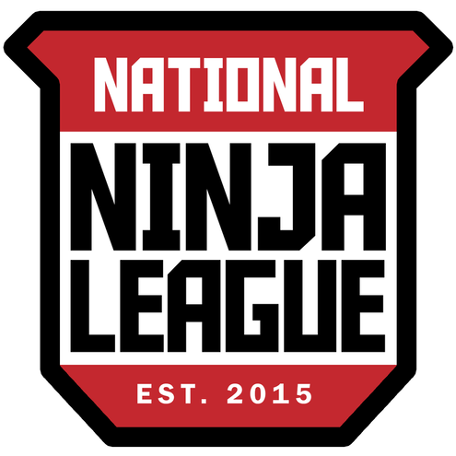
info@unwli.com
www.unwli.com
Birthday Parties – Classes – Mini Camps – Private Training – Scouts Events – Team Building – Competitions

